HOW TO

Excel Row and Column alternating colors.

Rows are most common, but columns work in the same way. This is what you want to see alternate colors for each row.

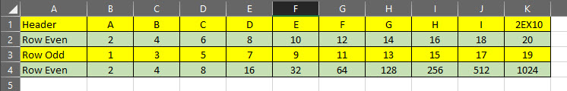

First the formulas

* For Even Row Color =MOD(ROW(),2)=0
* For ODD Row Color =MOD(ROW(),2)=1
* COLUMN For Even Column Color =MOD(Column(),2)=0
* COLUMN For ODD Column Color =MOD(Column(),2)=1

Next Select the area of the spread sheet you want to have the colors change.

Then from the drop-down menu under Conditional Formatting choose New Rule

Select Rule type of > Use a formula to determine which cells to format

In the box titled, “Format Values where this formula is true” paste in the Even Row Formula.

* Paste in this string =MOD(ROW(),2)=0

Then select the ‘Format’ button and follow the path to select the back ground color.

In the end it looks kinda like this.

